**Tomcat service Upgradation on windows server.**

**Assumptions**

This article assumes you have an existing server (real or virtual) with Apache installed on it.

Here are the steps to upgrade Tomcat Services:

1. Download latest version of tomcat from https://tomcat.apache.org/download-90.cgi.
2. copy the Tomcat file in the server.

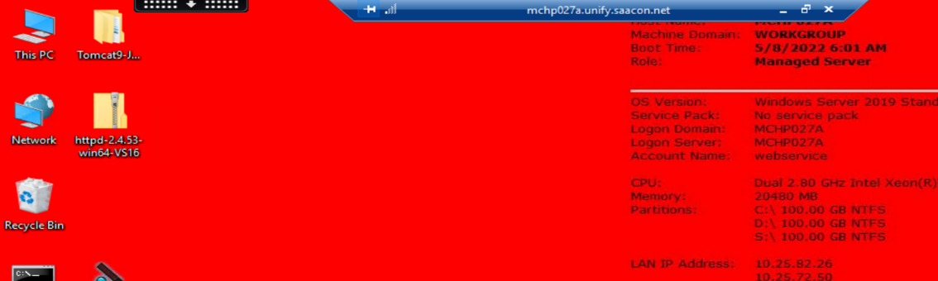

1. Check whether the tomcat service is running, its path and service name.

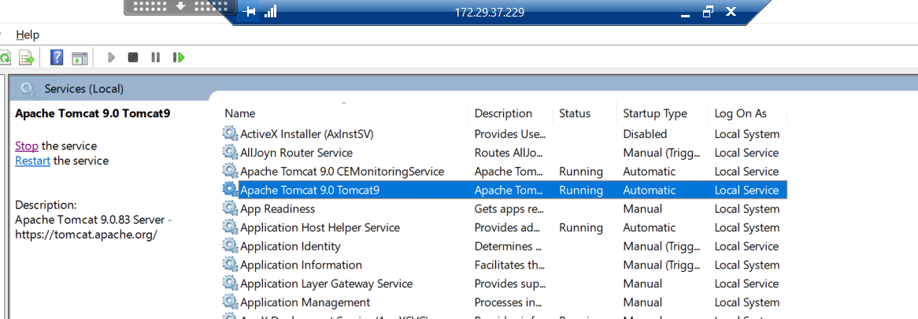

1. Stop the service running.

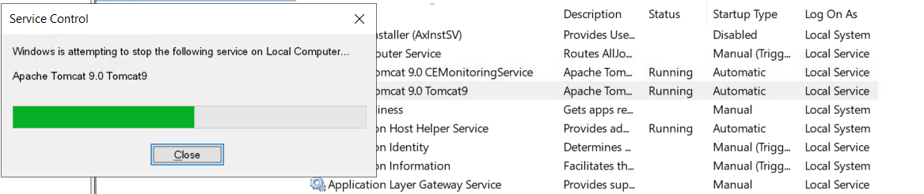

1. Backup the tomcat file running.

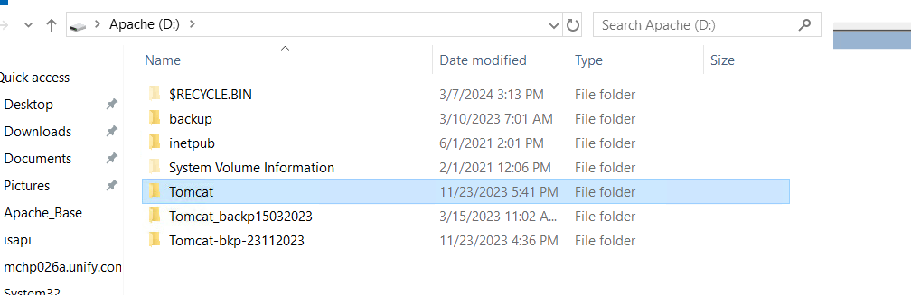

1. Check the connector port and shutdown port in server.xml file in the backup file and note it down.

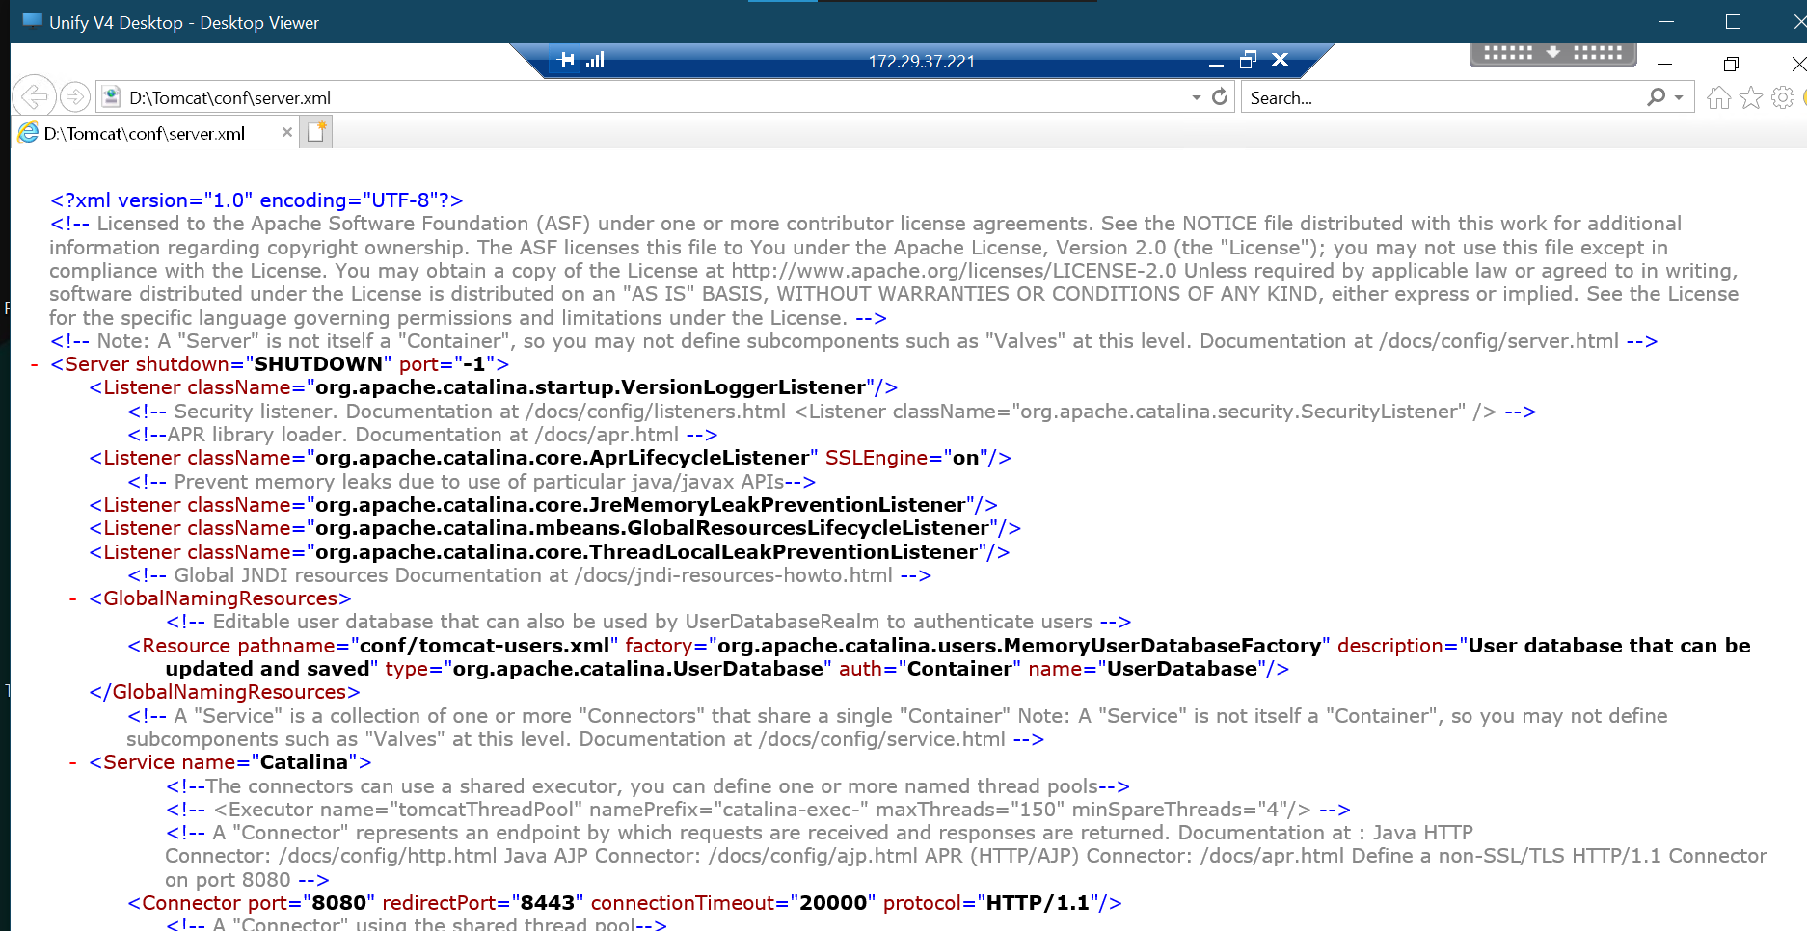

1. Now open the command prompt and delete the tomcat service running.

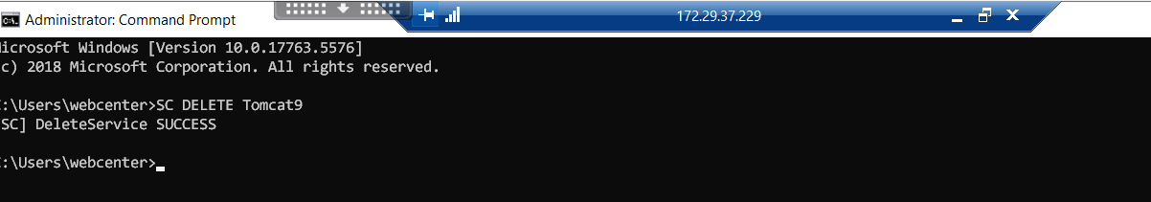

1. Now you can see the tomcat service is removed.

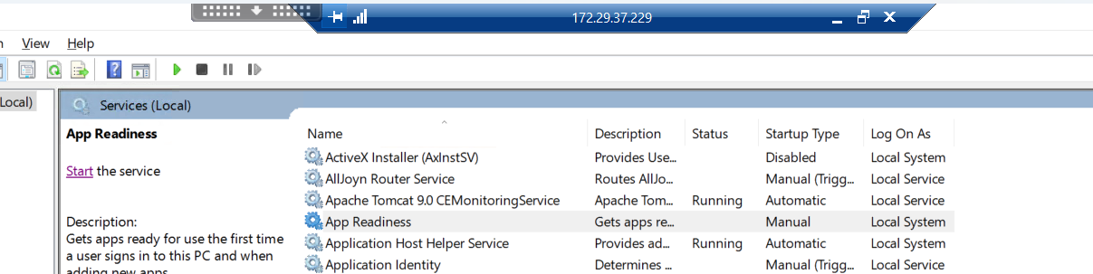

1. Create a new file in the path.



1. Open the tomcat.exe file.



1. Click next.

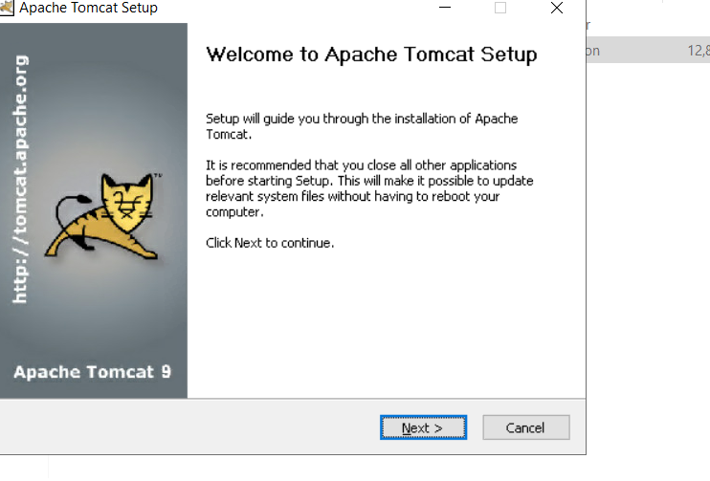

1. Click next.

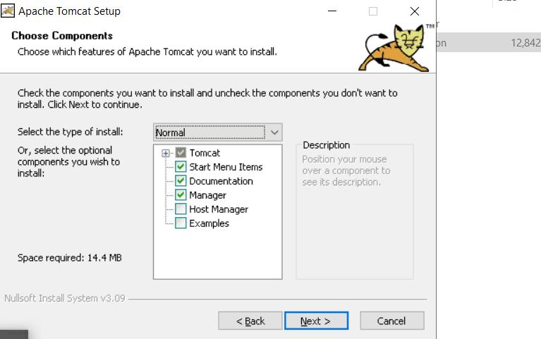

1. Specify the connector port and shutdown port.

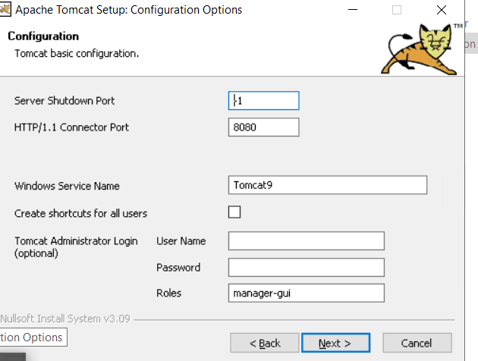

1. Click next.

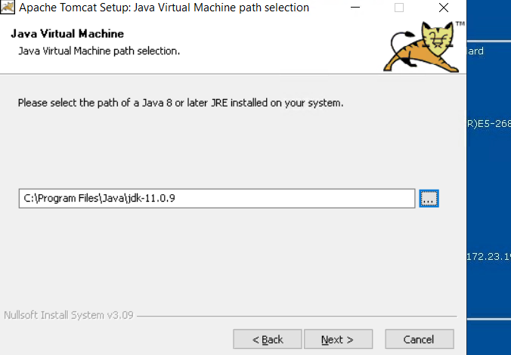

1. Change the destination path to new tomcat service folder.

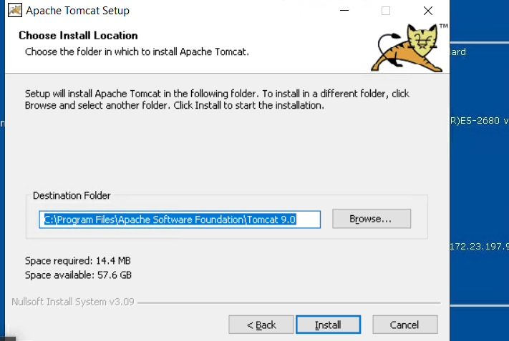

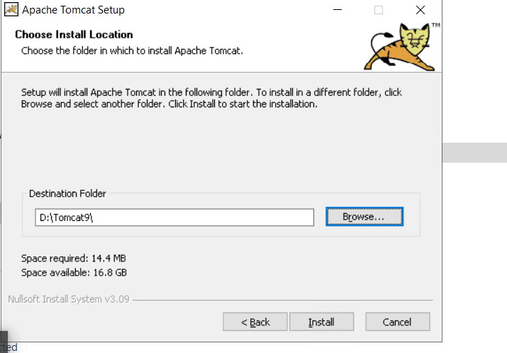

1. Uncheck both check boxes.

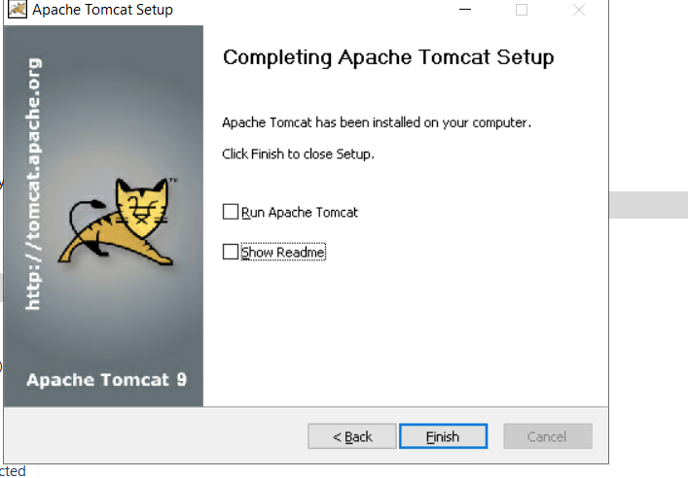

1. Now go to backup file and copy conf, lib, webapps, work and dxilib folders to new tomcat file.

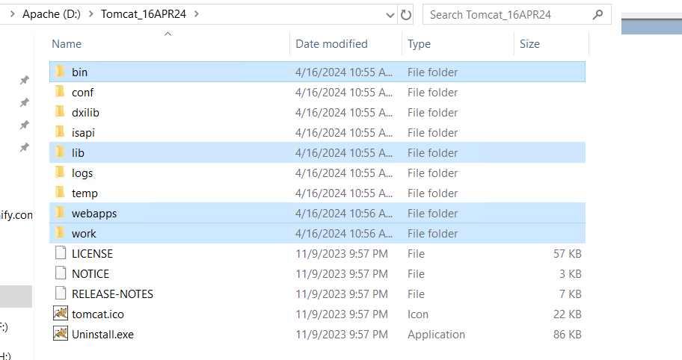

1. Go to services and start the new tomcat service.

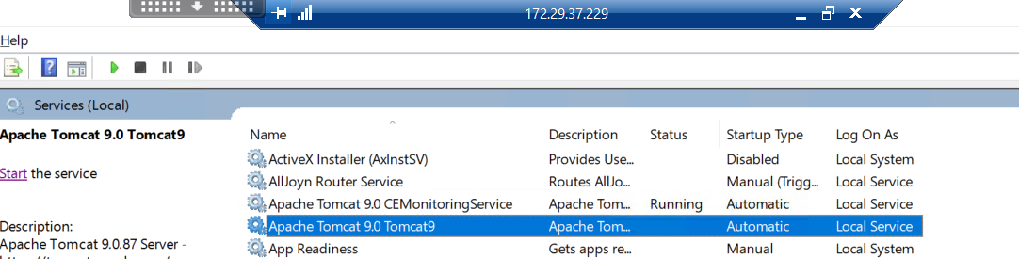

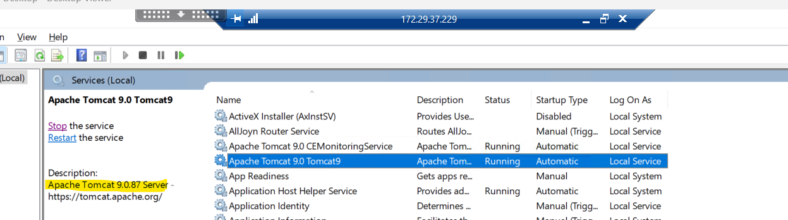

1. Now hit the url and check if the services are updated.

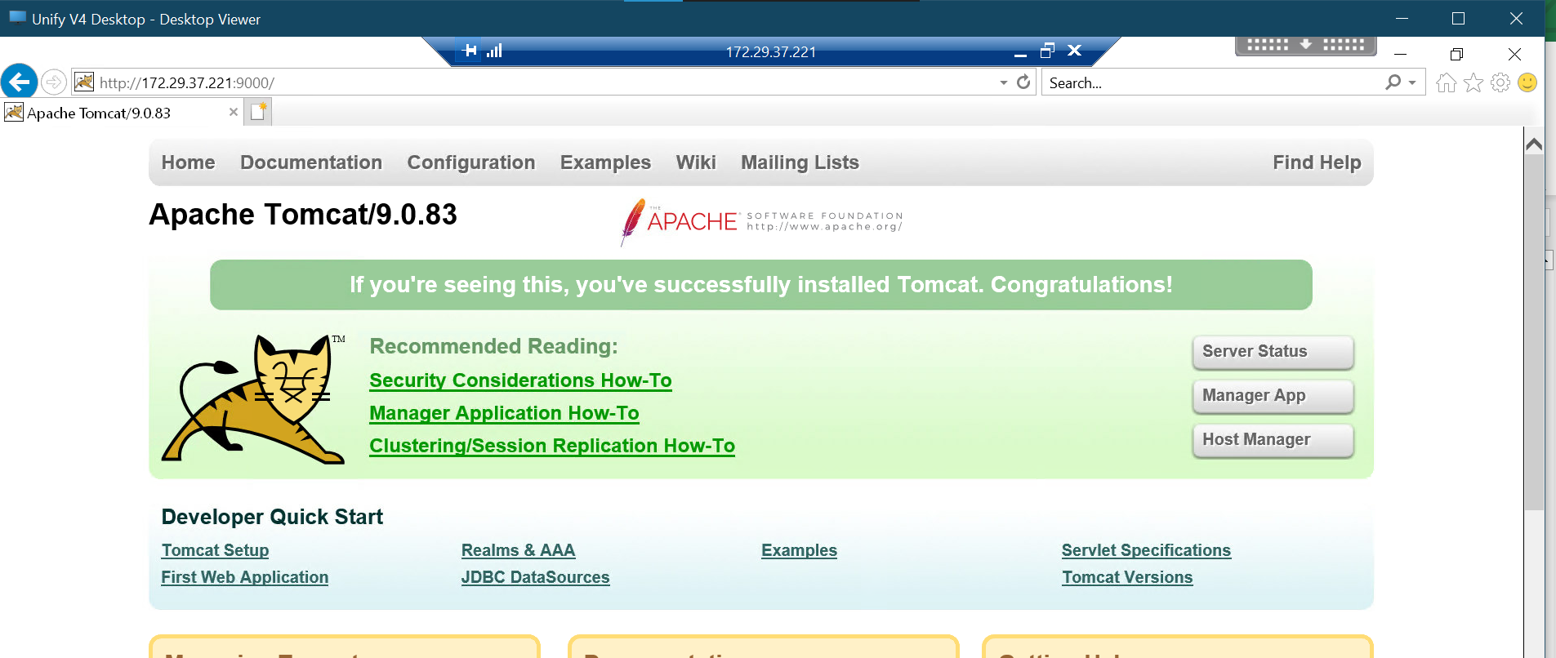

1. The tomcat services have been updated and completed.